74.07.16
From Edward Ramsay
MEL 292437, National Herbarium of Victoria, Royal Botanic Gardens Melbourne.

[…] (C. aust; & C. obstruens) the fronds were short & not long & wavy as in the others — I have no dried specimens
Livistonia Leichhardtii
17 A species of Livistonia is found growing on high barren ridges about 50 miles North West of Cardwell some nearer, it is called locally the Dwarf Cabbage tree I had not time last trip to go & see it, but intend to do so on this next tour
18 Livistonia australis very plentiful all along the Coast to the Clarence and Richmond, scarce at the Tweed & Brunswick. a small patch I know of near the Mary River and a few supposed to be the same sp. are to be seen as far north as the Burnett River — A Livistonia I noticed with more elongated fans more like those of Sabal Umbraculifera or S. Blackburniana is thinly scattered over the Herbert River district
My No 5. is quite distinct from any Livistonia I know of the leaves are almost peltate and the pinnae joined for more than ½ their length it forms a flat stiff shieldlike disc — look at a short distance as if quite peltate and entire or plicate
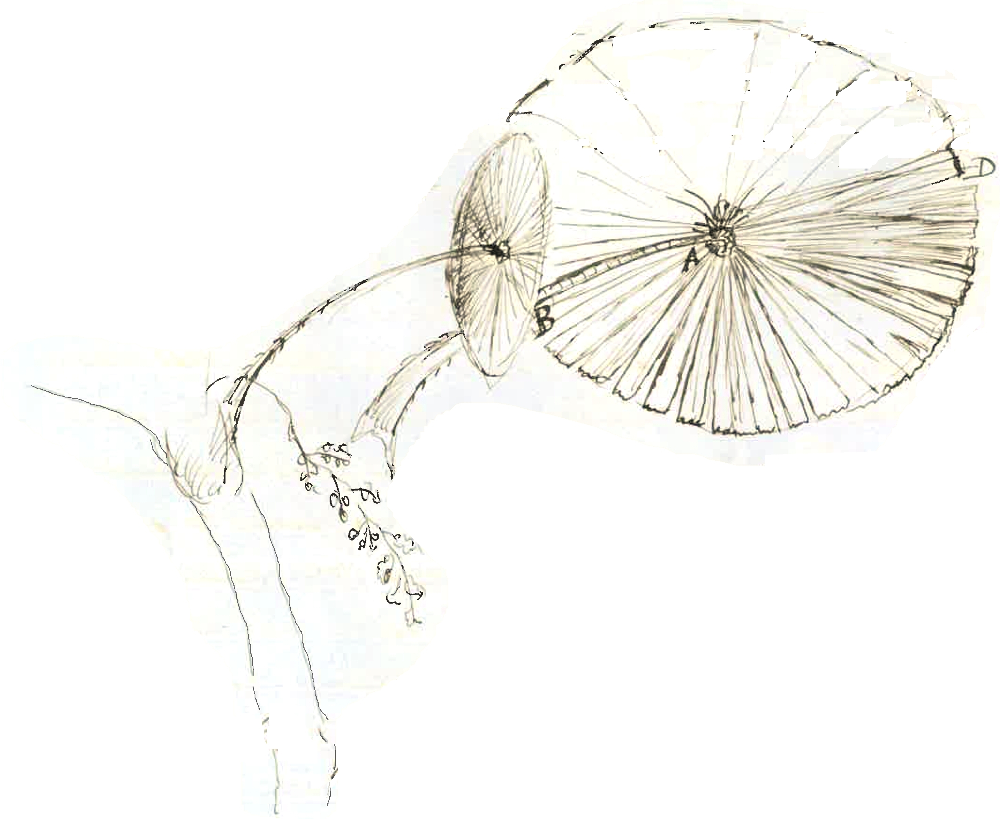
disc 6 to 8 feet in diameter on young trees 20 ft. high they are 6½ feet across
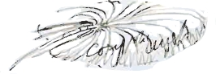
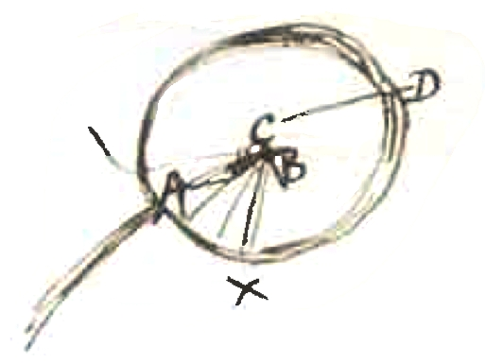
Hill found this or says he thinks he met it but had no specimens. I gave him seed — it is the only one of this form I ever met with. the sp. of Livistonia I have hitherto met with have more or less pointed pinnae and the frond of an elongated shape the pinnae are bent back towards the main rachis from the front part of it over the stem but in this the stem is almost at right angles with the disc formed by compound pinnae — I am not well enough acquainted with botanical terms to explain fully what I mean but perhaps my rude sketch may show you what I wish to point out — the outline of the frond is like this i.e. a little flattened towards the stem from the segments of the frond or fan being a little shorter on that side (as A to B) & B to A — one I measured was over 6 ft. 6 Inches being 3 feet from A to B and 3 ft 6 Inches from C to D. I used a leaf for an umbrella during a very heavy shower without getting wet at all
I would most willingly send you all my specimens but none (except living plants & seeds) have yet come down my cousin whom I left in charge of the Cutter &c has been ill with fever & ague for some two months and I am afraid my dried specimens have come to grief — If you think it worth while waiting I can send you immediately on my return spms of 5 or 6 distinct sp. of Palms But owing to the irregularity of the Steamer I am afraid it would be fully 6 or 8 weeks from now before you could get them & I should have to travel over an area of 60 miles to get them all perhaps more. If I send the men, some mistake may be made Hill has the flowers of what he thinks to be a new Areca — in spirits they looked to me like those of a Kentia he ought to have sent them to you long ago If I have success up North you need not trouble him for anything you shall have the whole of my collections, it is only your due I can send you living fronds and plants of 2 var of Cycas from Rockingham Bay and one from Rockhampton all said to be different & nuts of the latter sp
Hill found a Musa on the Johnstone River a tall black stemmed sp. ("30 ft. & over 18 In diameter" Hill) the sap when cut with a knife is of a reddish-lake color fruit said to be upright, there is a small Musa with black stem & upright flowers & fruit at Rockingham Bay — scarce, the common one with yellowish flowers & drooping spadix is I believe your Musa Banksii
The fern trees we know in commerce are (Australian) 1. Alsophila australis, 2 A. rebecca (Cardwell) 3 A. Leichhardti 4 A. cooperi; 5. a distinct sp. from Cardwell, long white [silky] scales otherwise like A. aust: 6 Dicksonia fibrosa (antarctica) 7 D. Youngii (Richmond River) 8 D. sp very like D. youngii
[…]

Livistonia sp? large Fan Palm from Coast Range near Dallachy's camp. Cardwell
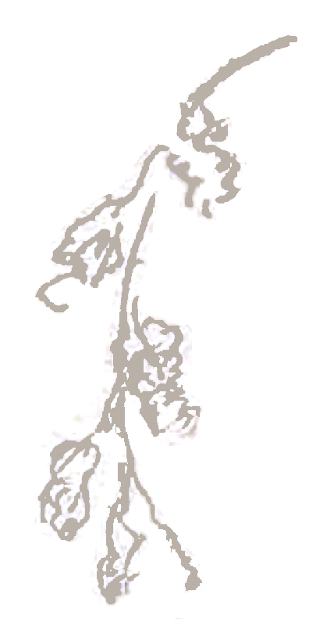
(Seeds round crimson in long stragling panicles

frond almost peltate — 6 feet in diameter
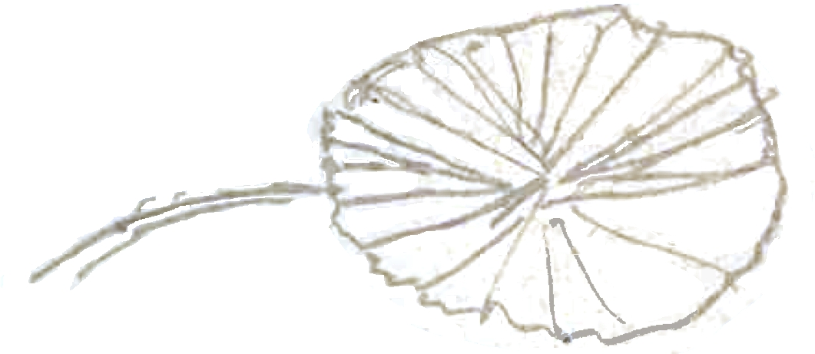

I found a thin-growing species on the Herbert-River and quite distinct from the two foregoing. The fruits were very small and hung 6-10 in clusters. The prickles on the stem were short and blunt, not long thin needlelike-spines as in C. australis & C. obstruens; the fronds were short, not long and wavy as in the others.

It is the only species I met with on the Richmond River. I did not meet with it on the Herbert River or on any part of the coast range near Cardwell.

I never met with this species otherwise than on the banks of the Herbert-River and the ranges about Cardwell. The young plants have the end pinna webbed and form a fishtail-end to the frond, but this is lost as the plant matures; the under-surface of old and young plant has a silvery bloom. This may be the same as seed N.1., but you will observe that the seeds differ not a little both in size and form.

I have received seeds of this species from the neighbourhood of Port Mackay; it is also found on the islands off the coast in that district. I found a Kentia with the seed-branches turned upwards against the trunc (not pendulous as in Seaforthia &c), the ends of the pinnae were shortened and toothed not unlike those of the Caryota urens

Alsophila australis
Alsophila cooperi
Alsophila Leichhardti
Alsophila rebecca
Areca
Calamus australis
Calamus obstruens
Caryota urens
Cycas
Dicksonia antarctica
Dicksonia fibrosa
Dicksonia Youngii
Kentia
Livistonia australis
Livistonia Leichhardtii
Musa Banksii
Sabal Blackburniana
Sabal Umbraculifera
Seaforthia

Letter attached to a specimen sheet of Licuala ramsayi (MEL 292437). Ramsay is named as the collector of the specimen, and the handwriting is his. Passages in the main body of the text appear to be responses to questions raised by M in his letter to Ramsay, 5 July 1874, as do the passages that we have placed at the end of the text, that M copied out from a letter (or letters) that he received from Ramsay, that we have for this reason appended here; two of these constitute the basis for our more precise dating of the present letter.
The upper portion of the sheet has been cut off; an unknown amount of text is missing.
Calamus australis and Calamus obstruens?
Livistonia leichhardtii has not been found but is Ramsay's usual spelling of Livistona at this time.
Over-written text from parts of the three MS lines of the preceding text has been removed from the sketch inserted here: 74-07-16_image01.jpg An image showing the text overlying the sketch is at Fig 2 of Barford and Dowe (2005). (Note that this letter fragment has since been redated.)
The sketch inserted here has one or perhaps two illegible words written across it: 74-07-16_image02.jpg
specimens.
A. rebeccae?
A. leichhardtiana (M's spelling) or A. leichhardtii (F. M. Bailey's spelling)?
Dicksonia youngiae?
Unknown amount of text missing.
This passage is in Ramsay's hand on a separate piece of paper of a different colour, attached to the same specimen sheet. Given the similarity of the sketch to the one in the main text, this may belong to a different letter.
A footnote marker has been inserted at this point in a darker ink, presumably by M since the note, in the same ink and his hand, appears on an accompanying scrap of paper: 'Dr E. Ramsay Folia fere peltatae, usque 6' diam. Albumen grosse latere intrusum Livistonia Ramsayi FM' [Dr E. Ramsay Leaves almost peltate 6' diameter all the way. Albumen [penetrated] laterally by a thick intrusion Livistonia Ramsayi FM].
Sketch to the left of the text: 74-07-16_image04.jpg
Sketch at bottom of sheet: 74-07-16_image05.jpg
Note in quotation marks in M's hand on a separate sheet headed 'Calamus australis? Fitzroy Island, Cunningham', and attributed to 'Edw. P. Ramsay, Asfield [i.e. Ashfield], Dobroyde Nursery, near Sydney 16/7/74'. The sheets bearing this and the following notes were extracted from specimen folders at MEL many years ago, with no details recorded.
Note in quotation marks in M's hand on a separate sheet headed 'Calamus australis!! caryotoides?' and attributed to 'Edw. Ramsay fol. 14'.
Note in quotation marks in M's hand on a separate sheet headed 'Ptychosperma Alexandrae' and attributed to 'Ramsay 16/7/74'. The passage appears to be a response to M's question about this species in M to E. Ramsay, 5 July 1874.
Note in quotation marks in M's hand on a separate sheet headed 'Kentia Wendlandiana | Cape Sidmouth, Dr Curdie! | Liverpool River, Gulliver'. M attributes the quoted passage to 'Edw. Ramsay'.

